How to Draw a Competitive Value Train Analysis

**(© 2016 David L. Rogers, from *The Digital Transformation Playbook:***

***Rethink Your Business for the Digital Age*)**

This guide provides detailed instructions for how to draw and use a Competitive Value Train Analysis. This tool is designed to analyze competition and leverage between a firm and its business partners, its direct rivals (symmetric competitors), and its asymmetric competitors.

As discussed before, an individual value train diagram is not meant to capture a company’s relationships with all of its customers (particularly not if it is a platform business with multiple distinct customer types). The aim of a value train diagram is to analyze one path for how a given offering (product, service, or a bundle of them) reaches a given customer or segment. For example, if you were a book publisher, you might use one value train analysis to examine how you sell via retail channels, and another for your online business.

The aim of the diagram is to clarify key dynamics in the creation and delivery of value:

* How does the offering reach the ultimate customer?
* What key businesses are involved in the process?
* Which participating firms have more leverage over the others?
* Where is symmetric or asymmetric competition present?

To create a value train diagram, you begin by answering three questions:

1. **Scope:** What is the value offering (product or service) you will analyze?
2. **Consumer:** Who is the ultimate consumer? Draw them as a **circle** on the far right of your diagram.
3. **Last firm:** What source does the customer receive the offering directly from? Draw this party as a **square** to the immediate left of the customer.
4. **Prior firms:** What other firms, if any, provide unique inputs to that firm? Draw them as additional **squares** to the left.

The number of squares, or “cars” in your value train will depend on your business model and means of distribution. Three broad types which are common as you move leftward, or upstream, from the consumer are:

* *Distributor*: delivers the product or service to the customer, although they may not manufacture it (e.g. retailers like Walmart, or e-tailers like Amazon)
* *Producer*: creates the finished product, service, or offering paid for by the consumer (e.g. an insurance company, record label, book publisher, or laptop manufacturer)
* *Originator:* creates unique elements or parts of the offering (e.g. chips or operating system for a laptop, or musicians creating recordings for a record label)

You can see examples of basic value trains with these three kinds of cars in Figure 3-10.

***Figure 3-10: Simple Value Trains for Laptop Computers and Recorded Music***

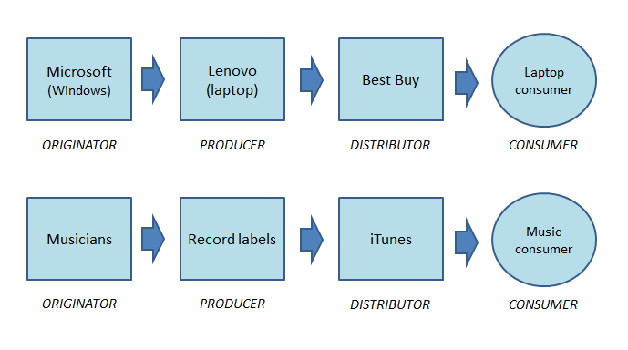

In these, and many cases, all three roles (originator, producer, distributor) will appear as separate businesses in the value train. In other cases, such as a fully-integrated firm which solely creates the offering and may sell it directly to the end consumer, there may be only one or two cars in the value train diagram.

After drawing the cars representing the key partners in your value train, the remaining four steps will highlight the competitive dynamics at play:

1. **Focal firm:** Which firm is the focus of your analysis? (e.g. your own firm, or another whose value train you are studying) Add an additional outline to the square around it.
2. **Value exchange:** Between each car, add arrows in both directions. Label each arrow pointed to the right to indicate what value is being delivered to the downstream party (e.g. product, service, or component of them). Label each arrow pointed to the left to indicate what value is being delivered upstream (typically, monetary, but there may be other value, such as data or marketing support).
3. **Symmetric competitors:** For each car in the train, identify the symmetric competitors (i.e. businesses that offer similar value, with a similar business model). Add them to diagram as rectangles below the car they compete with (e.g. if Walmart was in your value train as the final distributor, below it you would put a rectangle indicating other brick and mortar distributors).
4. **Asymmetric competitors:** For each car in the train, identify the asymmetric competitors (e.g. an alternate distribution channel, product producer, or component manufacturer that can substitute for the business, but has a different business model). Add them to the diagram as trapezoids above the car they could potentially serve as a substitute for.

**Ways You Can Use the Tool**

The Competitive Value Train can be used to analyze the cross-currents of competition and cooperation in any business’s path to delivering value to consumers.

It is particularly useful for understanding the forces of disintermediation (how an intermediary partner may be “skipped over” and cut out of a value train), or intermediation (what happens when a new distribution partner inserts itself between a firm and important customers or suppliers), as well as any shifts in the relationships between a firm and its sales channels or suppliers or both.

Recall the two power principles of value trains, introduced earlier in the chapter.

First, parties with more unique value at their stage in the value train (e.g. a uniquely influential producer, or distributor) have move power over partners. This principle explains the level of competitive leverage in many inter-firm relationships (e.g. why Walmart has so much influence over the brand manufacturers who stock its shelves).

Second, the parties at the ends of a value train (i.e. final distributors and original creators) have more power than intermediary producers in the middle. This power imbalance was famously described in manufacturing industries by Stan Shih, founder of computer maker Acer. Shih described a “smiling curve” where technology patent holders (my “original creators”) have high power to capture profits, as do companies who ultimately brand and distribute products (my “distributors”), but the product fabricators and manufacturers in between them (my “producers”) languish in a valley of low leverage and profitability.[1] The same dynamics have been observed in services industries, giving more power to the final “customer interface” (the last party in the value train, and in telecommunication and media industries, where unique content creators (like star journalists) and final customer discovery layers (like Facebook and Google) are accruing profits while traditional businesses in the middle of the value train are getting squeezed.[2]

Like the Platform Business Model Map, a Competitive Value Train Analysis can be conducted on the current state of a business, or as a forecast for potential new arrangement. The tool can therefore be used both to predict and assess possible moves by current partners in your value train, or to analyze possible moves that you are considering.

By example, Figure 3-12 shows two value train analyses of two examples seen earlier in the chapter: HBO’s decision to launch a direct online service for viewers (branded “HBO Now”), despite the importance of cable companies as its traditional distributor to consumers; and Allstate’s acquisition of Esurance, an asymmetric competitor to its own affiliated insurance agents, while continuing to sell through them under the Allstate corporate brand name.

Other plans for intermediation, disintermediation, or channel substitution, can be analyzed similarly, to forecast their potential outcomes and impact on competition and cooperation between firms.

***Figure 3-12: Value Train Analysis of Competitive Moves by HBO and Allstate***

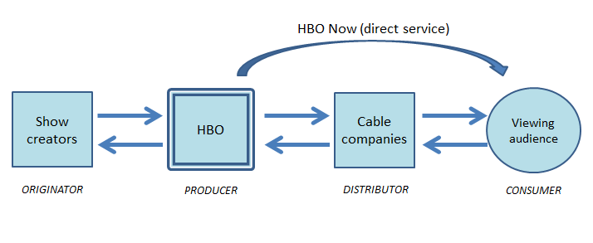

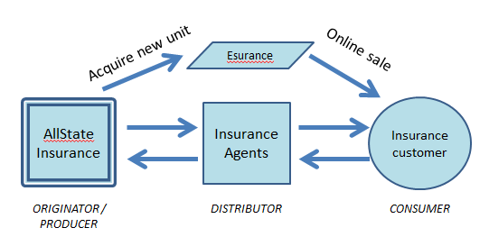

1. Jason Dedrick and Kenneth L. Kraemer, *Asia’s Computer Challenge: Threat or Opportunity to the World?* (New York: Oxford University Press, 1998), 152–57.
2. Ben Thompson, “Publishers and the Smiling Curve,” *Stratechery* (blog), October 28, 2014, https://stratechery.com/2014/publishers-smiling-curve/